**Lab: Entity-Relationship (ER) Diagrams Template**

1. Using this completed instance diagram fill in the cardinality symbols for the Entity-Relationship Diagram (ERD) below. You will probably need to use a basic drawing tool within Word to draw the cardinalities.

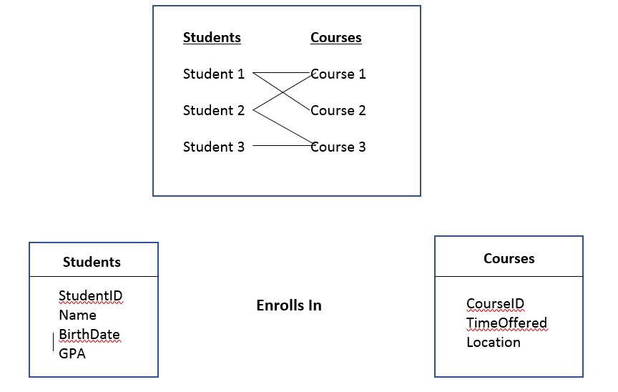

1. In the space provided below, draw an ER diagram containing Order and Customer entities connected by a 1-M relationship from Customer to Order. The relationship should be called “Places”. Define minimum cardinalities so that an order is optional for a customer and a customer is mandatory for an Order. For the Customer entity type, define attributes as follows: CustNo (primary key), CustName, CustBalance. For the Order entity type, define attributes as follows: OrdNo (primary key), OrderDate, OrdAddress.

Use ER Assistant to draw your diagram. Copy and paste the ERD from ER Assistant into the space provided below. [Note: To receive credit for this problem, you must use ER Assistant as your drawing tool.]

1. In the space provided below the following ERD, transform the following M-N relationship into an associative entity type and two identifying 1-M relationships.

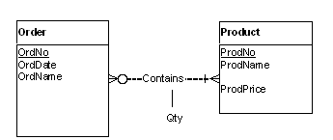

Use ER Assistant to draw your diagram. Copy and paste the ERD from ER Assistant into the space provided below. [Note: To receive credit for this problem, you must use ER Assistant as your drawing tool.]

1. In the space provided below, draw a self-referencing entity type for the Employee entity type for which an employee is supervised by a maximum of one other employee and doesn’t have to be supervised by any employee at all. Conversely, an employee can supervise zero or many other employees. The attributes of the Employee entity are as follows: EmpNo (primary key), EmpName, EmpAddress.

Use ER Assistant to draw your diagram. Copy and paste the ERD from ER Assistant into the space provided below. [Note: To receive credit for this problem, you must use ER Assistant as your drawing tool.]

1. In the space provided below, draw a generalization hierarchy containing Employee, Administrator, and Faculty entities. The Employee entity is the supertype, and the Administrator and Faculty entities are the subtypes.

The Employee entity has attributes as follows: EmpNo (primary key), EmpName, and EmpAddress.

The Administrator entity has attributes as follows: AdmTitle, AdmContractLength

The Faculty entity has attributes as follows: FacTenure, FacRank

The generalization hierarchy should be disjoint but not complete.

Use ER Assistant to draw your diagram. Copy and paste the ERD from ER Assistant into the space provided below. [Note: To receive credit for this problem, you must use ER Assistant as your drawing tool.]

1. In the space provided below, draw an ER diagram that includes entities for Clients, Contracts, and Contacts.

Clients have the following attributes: ClientID (primary key), ClientName, ClientAddress.

Contracts have the following attributes: ContractID (primary key), ContractType, LicenseFee.

Contacts have the following attributes: ContactID (primary key), ContactName, ContactAddress.

Draw a relationship between Clients and Contracts such that a Client can be assigned to many contracts, but it can also exist without having any contracts at all in the database. Conversely, a contract can be assigned to only one client but must be assigned to a client in order to exist. Name your relationship “Signs”.

Draw a relationship between Clients and Contacts such that a client must be assigned to one and only one contact. A contact can exist in the database without being assigned to a client, but a contact can be assigned to more than one client. Name your relationship “Has”.

Use ER Assistant to draw your diagram. Copy and paste the ERD from ER Assistant into the space provided below. [Note: To receive credit for this problem, you must use ER Assistant as your drawing tool.]

1. Identify two problems with the ER diagram below:

Registers relationship is reversed.

CourseNo in Offering is not required.

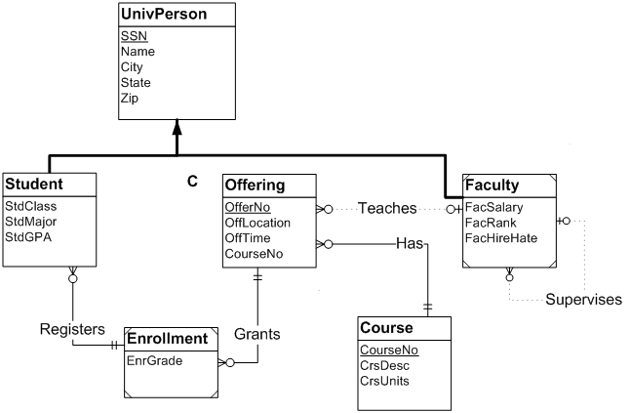

Use the following ERD to answer the next 2 questions:

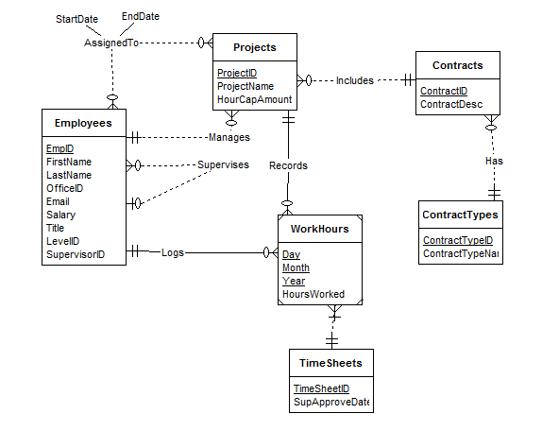

1. What is the primary key of the WorkHours table?

Answer: Day, Month, and Year

1. Indicate the redundant field in the Employees table.

Answer: SupervisorID

1. Short Answer:

When converting the ERD to a table design, how should you handle the AssignedTo relationship? (Be sure to include a discussion of primary keys, foreign keys, and tables in your answer.)

Answer: An arrow would be pointing from EmployeeID to ProjectID in the table and thee primary keys would be the first entry of each table. The foreign keys would be the Start and End dates.

1. True/False

ProjectID will be a foreign key in the Employees table to reflect the “Manages” relationship.

Answer: True

1. After converting the ERD to a table design, what fields will be present in the Contracts table? Indicate the primary key of the table by underlining the appropriate field(s).

Answer: Contract ID, Contract Description

1. Short Answer:

WorkHours is a weak entity.

What would you do to transform it into a strong entity?

Answer: To convert WorkHours to a strong entity we would have to change the entitis that it is dependent on into dependent entities.

14. Short Answer:

Would it be desirable to change WorkHours into a strong entity? Why or why not?

Answer: No, This would mean that the whole ERD would be focused on the WorkHours rather than the Employees, which has the most attributes and is the most identifying entity.